EXPERIMENT 11

11.1.1// Remove Punctuations from a String
ALGORITHM:
Step 1: Start
Step 2: Input a number → num
Step 3: Initialize sum = 0
Step 4: Repeat while num > 0:
  - Extract last digit → i = num % 10
  - Add it to sum → sum = sum + i
  - Remove last digit → num = num // 10
Step 5 Print the value of sum
Step 6: End

FLOWCHART:
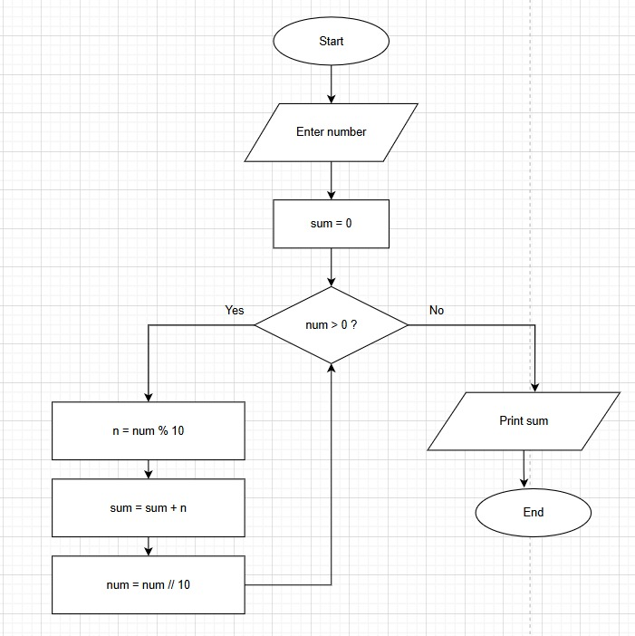
CODETANTRA:

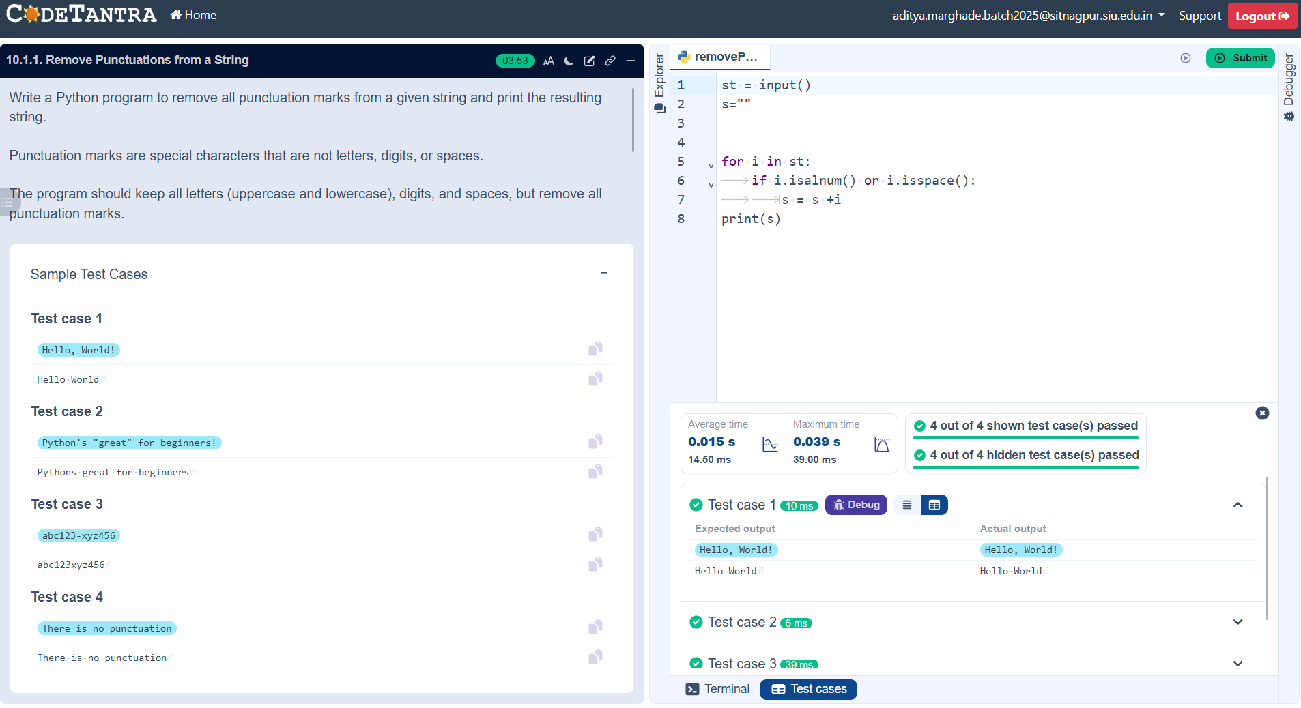

11.1.2// Reverse a String
ALGORITHM:
Step 1: Start
Step 2: Define function sum_of_digits_recursive(n)
Step 3: Check base case:
  - If n == 0, return 0
Step 4: Otherwise:
  - Extract last digit → n % 10
  - Call function again with remaining number → n // 10
  - Return their sum
→ n % 10 + sum_of_digits_recursive(n // 10)
Step 5: Take input number → number
Step 6: Call function → result = sum_of_digits_recursive(number)
Step 7 Print result
Step 8: End

FLOWCHART:
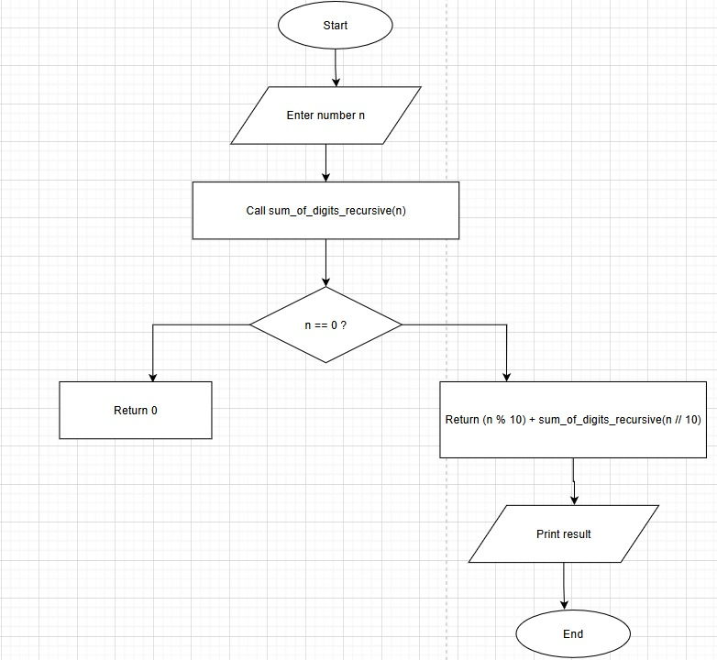
CODETANTRA:
